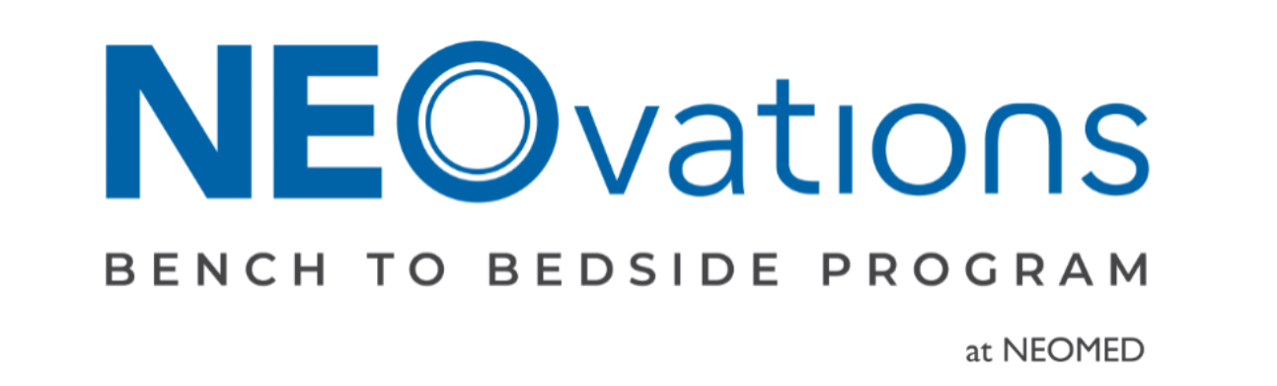
Sixth Annual Competition Packet
2025-2026
Instructions: Please limit your responses to 500 words per question. You are encouraged to include photographs, tables, diagrams, or other visual elements to effectively support your ideas. The completed document must be submitted as a PDF. Prior to submission, carefully consider the aesthetics of your packet to enhance the overall presentation. This document will be reviewed by competition judges and serves as a key component of your proposal. Please note that this is the only accepted template for submission, and any alterations to its structure or format will not be permitted.

Select this Textbox and Paste Your Logo.
Please Maintain this Size.

Delete if NOT Applicable
Type Product Name
- Overview

  - What is the name of your technology?

  - Please list team members and provide pertinent affiliations and institutions for all listed.

  - Who is your clinical and/or academic mentor for the project? If applicable, list any consultants. Please provide pertinent affiliations and institutions for all listed.

- Present Your Product

  - What clinical need does your product address? Please elucidate the prevalence of the clinical need and the associated demographics.

  - What is your solution to the unmet clinical need you selected?

  - What are the current competitors to your product or technology?

  - In what ways does your solution provide advancements or unique advantages compared to existing technologies or products?

  - Please show a photograph or image of your design and/or describe your design in detail.

  - What testing, if any, have you completed for the performance and safety of your product?

- Business Strategy

  - Describe your business market. (Who is buying the product? What does the current market look like for similar devices? What is the projected growth of that market?) Please provide evidence to support your market analysis.

  - What is your value proposition? Please provide evidence to support this proposition.

  - What is the pricing strategy for this product? How have you addressed affordability of the product?

  - What do you see being the biggest hurdle to bringing your product to market?

- Customer Discovery

  - A minimum of 10 interviews is required to be considered eligible for the competition. Please list the professional demographics that you used to source your interviews. In addition, please write a brief description of how your three most important interviews guided your thinking in the development of your technology.

- Regulatory and Intellectual Property

  - Include FDA device classification (see: https://www.fda.gov/medical-devices/overview-device-regulation/classify-your-medical-device for clarification), if applicable.

  - Please describe your IP Progress.

- Legacy Teams

  - Is your team a Legacy Team? (Product was previously presented at Bench to Bedside)
Yes or No.

  - If yes, please describe the progress made since the previous year’s competition.

- Disclaimer

As NEOvations Bench to Bedside continues to grow, we would like to promote teams and projects on various social media platforms and news outlets. If you and your team are interested in potentially being featured in future posts on social media outlets (i.e.. LinkedIn), please check the box below next to “We Agree.” If you and your team do not wish to potentially be featured in future posts on our social media outlets, please check the box next to “We Disagree.”

We Agree

If you check “We Agree” and would like to write a brief description that highlights your product, please include it below.

We Disagree

