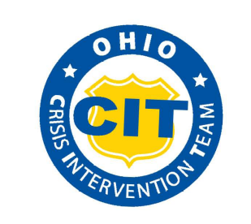

2019 CIT Advanced Training Conference Crisis Intervention Registration Form
October 18, 2019|State Highway Patrol Training Academy|740 East 17th Avenue. Columbus, Ohio 43211

Name:

Specialty/Profession:

Organization/Program:

Address:

City: State: Zip Code:

County: Telephone:

E-mail:

Special dietary needs or special accommodations needed:

Conference registration is $25 per person

Please check all that apply:

❒ Purchase Order Number:

❒ Pay with Check at Door of Event

❒ Interested in a Scholarship

Please email, mail, or fax completed registration information to: Northeast Ohio Medical University
Attention: Haley Farver
4209 St. Rt. 44
PO Box 95
Rootstown, Ohio 44272
Fax: 330-325-5970

Contact Haley Farver at hfarver@neomed.edu with any questions.

